

Indoor Mini Helicopter

Instruction Manual

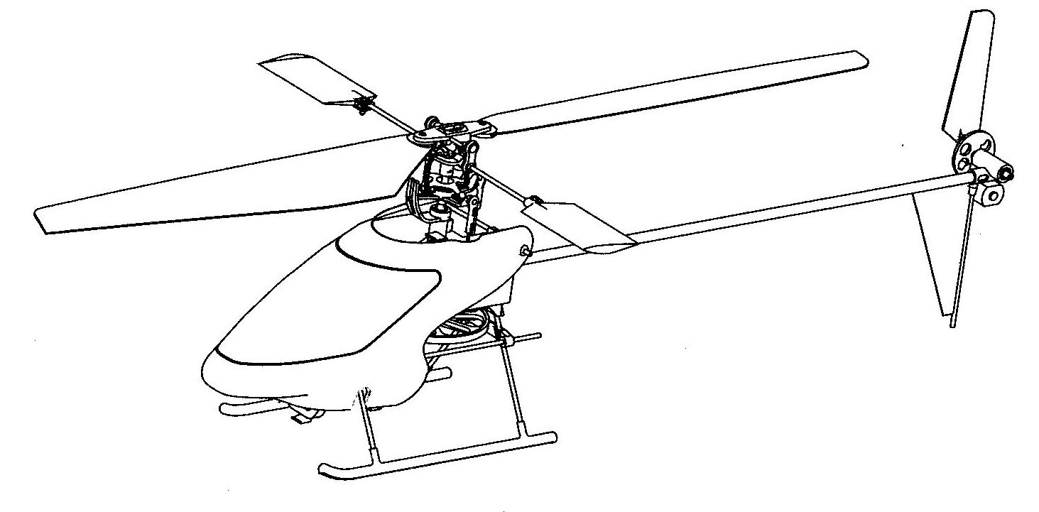

Part I
Construction Guide

Congratulations on your purchase of this excellent almost-ready-to-fly indoor mini helicopter! Dragonfly is designed by expert engineers and built by skilled craftsmen.` Most of the parts have been assembled and installed at the factory for you, yet the ultimate success or failure depends upon yourself. Since helicopters are more difficult to assemble and fly than fixed wing aircrafts, you have to read and understand the entire Instruction Manual before you begin to work on it and to fly.

WARNING

R/C model aircrafts are not toys. They are capable to cause serious injury and/or damage if not assembled, operated and maintained properly. The helicopters are more dangerous than the fixed-wing aircrafts. If you are a newcomer, we strongly suggest that you find an experienced helicopter pilot to assist you.

WARRANTY

We guarantees this kit to be free from defects in material and workmanship at the time of purchase. This warranty does not cover any component parts damaged by use, modification or deterioration resulting from the application of adhesives or other products not specified in the instructions. In no event should our liability exceed the original purchase price of the kit. Besides, we reserves the right to change or modify this warranty without notice.

COMBO DRAGONFLY HIGHLIGHTS

We supply Combo Dragonfly which includes:
- The Kit virtually assembled and installed at factory.
- Mini receiver, mini servos, speed controller, mixer and gyro.
- Transmitter especially designed for helicopter use.

SPECIFICATIONS

- Main rotor diameter: 520 mm.
- Fuselage length: 500 mm.
- Max all-up-weight : 300g.
- Power: 8.4 v. Ni-Mh
- Radio: 4-ch. / 2 mini servos

BASICS

1. How does a helicopter fly?

Instead of fixed wings, a helicopter has rotating wings, the rotor blades, to generate lift, just like the propeller to generate thrust. The lift increase with engine speed or the pitch angle of the main rotor blades. For simplicity, our mini helicopter only controls the engine speed to increase or decrease its lift. However, a motor driven system simultaneously generates torque that acts on the helicopter fuselage, twisting the fuselage in the opposite direction to the main rotor. This torque has to be countered by the thrust of the tail rotor blades installed on the end of a tail boom. It is the mixer that co-ordinates the speed of the main rotor and the tail rotor so as to alter the thrust of the tail rotor and exactly balance the main rotor torque. By increasing or decreasing the speed of the tail rotor and hence varying its thrust, the helicopter yaws either left or right. Besides, a helicopter must also be controlled about two further axes: roll and pitch. This task is performed by the cyclic control system.

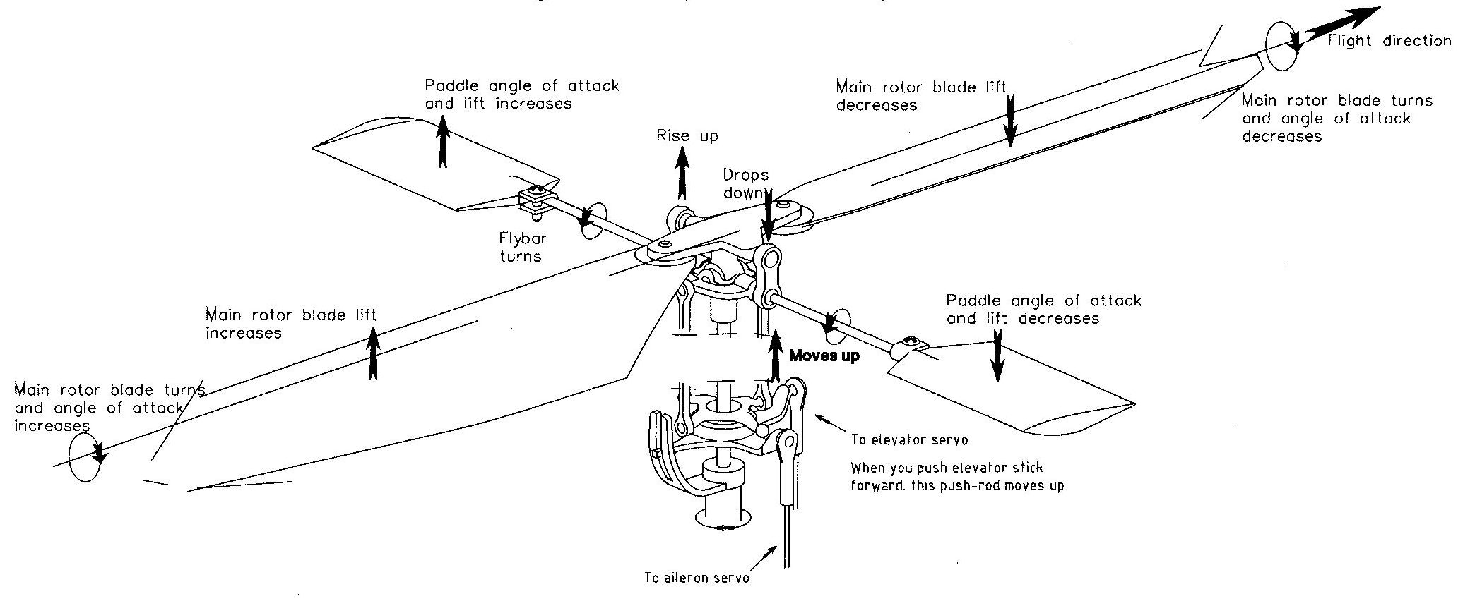
Fig 2. The cyclic control system

2. The cyclic control system

If the helicopter is in hover, both rings of the swash-plate and the rotor disc are at right angle to the rotor shaft. When flying in a certain direction, i.e. forwards, backwards or sideways, swash-plate should be slanted and tilt the rotor disc in that direction in order to provide the thrust component required. This is accomplished by the cyclic control system.

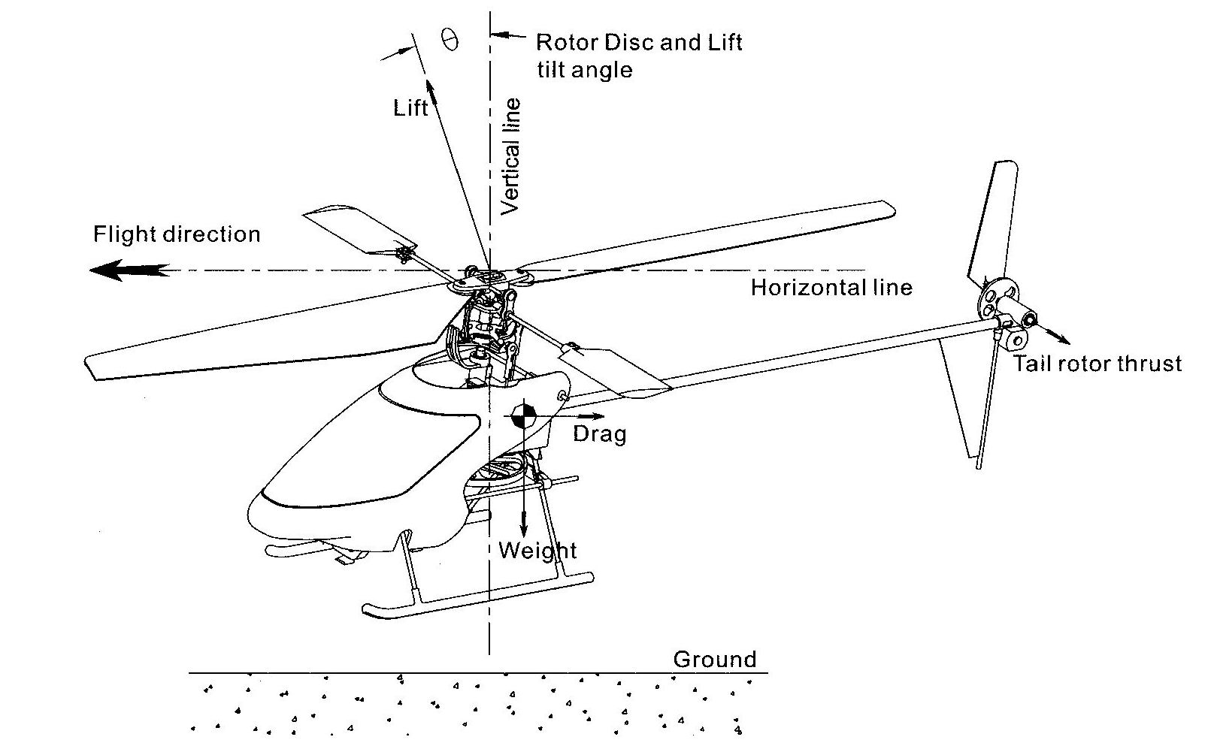
Fig. 3 Forces acting on a helicopter when flying forwards

Let's see how the cyclic control system works when the helicopter is flying forward. Referring to Fig.(2), when you push the elevator stick on your transmitter forward, the push-rod linked to the elevator servo moves upwards, this push-rod tilts the outer ring as well as the inner plate of the swash-plate. And, the push-rod linked with the inner plate also moves upward and turns the flybar paddles such that one of the paddles increases its angle of attack and lift while the other decreases its lift. Therefore, one paddle rises up and the other drops down, which in turn, via linkage, connected to the rotor head as shown in Fig.(2), make the main rotor blades turn around its axis such that the advancing blade decreases its angle of attack and lift while the retreating blade increases its angle of attack and lift. Hence, the lift at the rear of the rotor disc is increased while at the front it is decreased. Consequently, the rotor disc, and the whole helicopter with it, tilts forwards and provides the forward thrust component required for the helicopter to fly forwards. On the contrary, when you pull the elevator stick backward, the helicopter will fly rearward. Similarly, when you push the aileron stick left or right, the helicopter will roll left or right.

FINAL ASSEMBLY

Since this mini helicopter is virtually assembled at the factory, what you need to do is to install the radios, battery and connect the control linkage before adjusting and flying.

1. Installation of the servos

- Use double-sided adhesive tape to firstly try-glue the elevator servo to the surface of the frame in front of the main rotor shaft behind the main motor. And, the roll servo to the surface of the frame on the right-side of the main rotor shaft.
- The elevator push-rod is to be attached between the servo-arm and the rear ball on the outside ring of the swash-plate. And, the aileron push-rod is linked to the side ball on the outside ring of the swash-plate.

2. Radio connections

- Connect all the leads except for the flight battery as shown in Fig.(4). The leads emerging from any component must be positioned so that under no circumstance will they come into contact with any of the machine's moving parts.

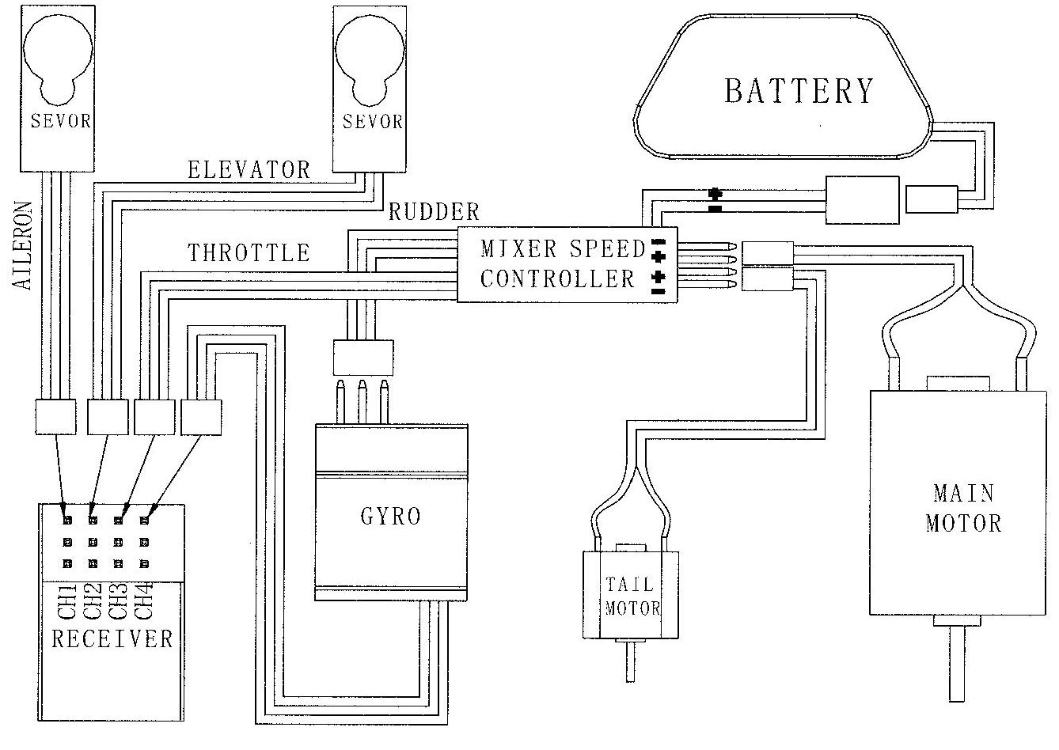
Fig. 4 Scheme of Connections

- Place the battery pack in between the battery holders (#5031 and #5032) and join the two holders with a rubber band. You can shift the battery pack fore and aft to adjust the balance and get the proper CG position.
- Lead the receiver antenna out of the cabin area and attach it with tape to one of the kids, leaving approximately 10 cm. of it hanging free. This is of great importance and should be done exactly. WARNING: Do not run or tape the antenna alongside any carbon fibre components as this may cause un-expected radio inference.

3. Adjustment

- Remove the servo horns (i.e. the arms or discs) from the servos.
- Set transmitter trims to their neutral positions and pull the throttle stick to its lowest position (i.e. power off position). Plug in the battery pack and turn on the transmitter to get the center positions of the servos. Then, mount the servo horns again and secure the horns with the screws.
- Un-plug the battery pack for now. Attach the push-rod to the servo-arm at the outer hole of the arm. Press the ball link of the elevator push-rod onto the rear ball of outside ring of the swash-plate. And, the aileron push-rod onto the left-side ball of the outside ring.
- Position the elevator servo such that the swash-plate is level and the linkage F-les up straight. Pull the servo back just enough to drip some CA and press the servo against the mount area for a few seconds until the glue cured.
- The roll servo is positioned and fitted the same way. Place the ball link of the aileron push rod onto the ball on the outside ring of the swash-plate. Center and level the swash-plate as per the elevator servo.
- Make sure that the swash-plate should now be level and perpendicular with the main rotor shaft. The servo horns should be perfectly horizontal with R/C switched on, transmitter sticks and trims all centered.
- The main rotor blades are already attached to the rotor head at the factory. You just need to adjust the mounting screws and nuts. They just need to be tight enough to prevent them from pivoting into the helicopter when they are at rest. But, if over-tightened, the helicopter may shake and vibrate. Nevertheless, if they are too loose, the helicopter will be un-stable as the blades spin up.
- Adjust the positions of the flybar paddles such that they are at the same distance from the rotor head.
- Finally, shift the battery forward or rearward until the model balance level when suspended by the flybar as shown in Fig.(5)
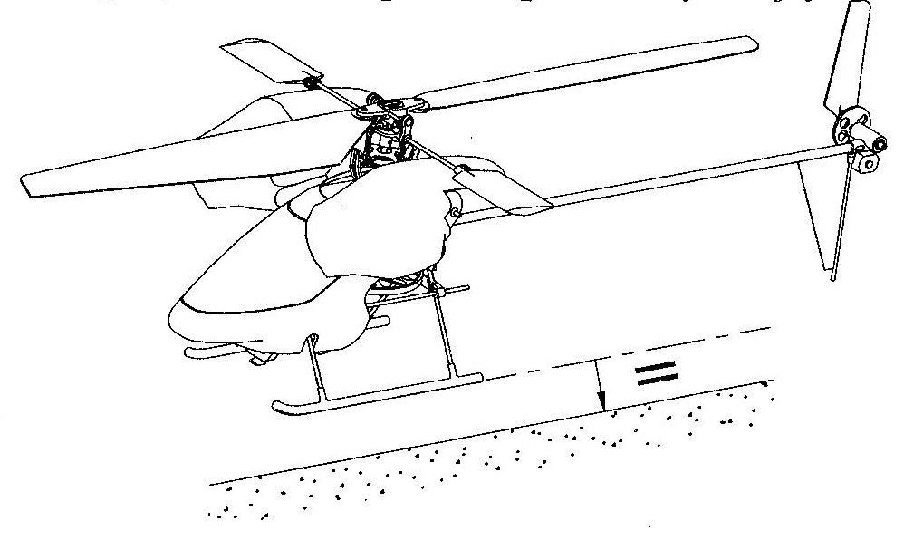
Fig. 5 The helicopter suspended by the flybar
BEFORE FLYING

Now, turn on the transmitter again. WARNING: Only turn on the transmitter after you are sure that the throttle stick is at the lowest position and your transmitter throttle reversing switch is correctly set. Should the flight battery be connected at high throttle setting, it would result in severe damage or personal injury.
Keep fingers, loose clothes and eyes well clear of rotate-able parts whenever you connect the flight battery to the speed controller.

- Center all the trims. Move the throttle stick to the lowest position. Plug the flight battery into the speed controller and let the Mini Heli sit for 5-7 seconds until the controller LED illuminates. Do not move the machine while the system is calibrating.

- When the LED grow green, the electronics are active. Hold the throttle stick in the power off position and check the cyclic controls. Move the elevator stick back and forth and make sure that the swash-plate moves in the right direction. Move the aileron stick from side to side and confirm that the swash-plate is also operated in the right direction. Check the integrity of all controls and the correct operation of flybar paddles along with the main rotor blades.

- Now, gently apply a tiny amount of throttle. The main rotor will begin to rotate first, then the tail rotor. Throttle down again and un-plug the flight battery.

- Don't forget to fully charge your flight battery. When the Mini Heli landing slowly and failed to fly up again, or when stay on the ground, rotor speed slowed down or servos lost of control, the batteries require to be re-charged. IMPORTANT: When charging new batteries, charging current should never exceed 0.35 A.

Part II

FLYING THE DRAGONFLY

WARNING: If you are a beginner, you must seek assistance from an experienced R/C model helicopter pilot. You should be aware that the main rotor blades and tail rotor blades spin at a very high rpm and are capable of injuring someone if hit by them. You must take care when you are flying to make sure there are no children or animals in the room. In addition, make sure the room is large enough with no obstacles such as furniture which could be hit while you are learning to come to terms with the flight characteristics of your Dragonfly.

Suitable flying space should be indoors in a large room or if possible, a small hall or office without obstacles is ideal. In this room you should have all doors closed as any wind can affect the movement of the Dragonfly. If there is air-conditioning or heating in the room, this should be turned off until you get used to the characteristics and feel of the helicopter.

Make sure the take-off floor is a smooth surface and be prepared until the flight rpm has been reached that the helicopter might slide around on the floor. We suggest that you avoid using carpet for your first flights as this can cause the skids to catch and cause the helicopter to flip over.

Step l

First check that all the controls are correct. We suggest you loosen off the two screws of the electric motor and slide it away so that the pinion gear from the motor is no longer engaged to the main gear. Now turn your transmitter on followed by plugging in the helicopter. Centre all trims and pull the throttle stick down to the bottom. Please note at this stage that you might have to adjust the throttle trim so in this position, the electric motor is not turning.

Next check the swash plate is level. To adjust this, use the trims on your transmitter for forward and aft and left and right cyclic.

Once you have achieved all these initial settings, unplug the helicopter from its battery and turn the transmitter off. Re-engage the electric motor and make sure that you do not make the gear mesh too tight between the pinion gears and the main drive gear. To achieve this slide through a piece of paper between the two gears so there is slightly backslash.

In the appropriate room which is quite large and with no obstacles, place the models in the middle, turn the transmitter on and plug in the flight battery and wait until the LED light is activated. Then test that the servos operate properly but please remember do not apply any throttle. Keep the throttle stick at the off position.

If everything is working correctly, position yourself at least 2 metres behind the helicopter and slightly off to one side. Please be sure that you are able to see the nose of the helicopter.

Please note when flying that you always watch the nose of the helicopter. If the nose of the helicopter twists to the left, you are then required to give right tail rotor to correct this (for example when using Mode I type radio, you push the left hand stick to the right). Watch the nose and slightly apply enough throttle until the model becomes light on its skids.

All helicopters exhibit a small amount of unavoidable drift on takeoff due to the side thrust of the tail rotor and also the turbulence coming from the main rotor blades which is called "rotor wash". This is mainly noticed as drift to the left just before takeoff. Therefore it is possible that the machine will tend to yaw its nose to the left or right when a small amount of power is applied, then straighten up when more power is applied to give authority to the model.

Observe whether or not the helicopters tips forward or backwards. If it tips forward, you will need to apply elevator trim towards the rear. This is reversed if it tips the other way. Do this until there is no more detectable forward or backwards or even sideward tendencies.

Always when applying the throttle, please apply it softly. Too much throttle will make the helicopter climb too quickly and you may have difficulties in correcting it quickly enough.

Step 2

First flights should be what are called "bunny hops". This is initially applying a slight amount of power to get the machine light on its skids.

Once this has happened, apply more power to lift the machine so it is approximately 30 centimetres off the ground. Watch for any change of direction of the model. If you cannot correct it immediately, decrease the throttle and land.

This is the initial technique to learn to fly. You must do this until you believe you are starting to put in the right correction commands to keep the helicopter in one spot. How many times and how many batteries you will achieve this in will depend on your ability to become familiar with the feeling and feedback from the model.

At the preferred height of 30 centimetres which we find is best for flight training, always make sure you watch the nose of your helicopter not the tail. Keep practicing and you will find that your flights will become longer.

Also please note that depending on the size of your room, after a few minutes the air circulating around the room can cause some turbulence created by the model. If you find this is off-putting, we suggest that you land and let the air settle.

Please remember that model helicopters no matter what type will never stay still. They will always require some form of input to stop the drift or the tendency to turn. This is not a sign of something faulty with the helicopter, but more the nature.

As you become more familiar with your helicopter, you will find that your hand and eye coordination will enable input to correct the movement of the helicopter as soon as it starts, and this will start to show smooth flight.

Step 3

Once you believe you are now familiar with the basic hovering of your helicopter, you should now start experimenting with turning the helicopter slightly to the left or right using the tail rotor (yaw).

Please note always remember if you have turned your helicopter to the left, if you get into any trouble, yaw the helicopter back to the right so you have the tail pointing at you for easier reference. We suggest that you turn the model some 45 degrees towards you always remembering to watch the nose.

Takeoffs are a little easier than landing. This is due to the ground effect turbulence of the rotor blades. However spot landing at a modest rate of descent is not as difficult as it might seem. As you become more proficient with your helicopter finding a larger hall so you can start to fly around more or even on dead calm days, by going outside you can achieve some forward flying circuits. If you do fly outside, please remember any wind will affect the performance of the humming bird. Please keep this in mind and do not get surprised if it suddenly climbs or drops without you making any input. This can be caused by a slight breeze or even a thermal wind coming through.

Remember practice makes perfect and even we suggest buying a computer flight simulator can greatly enhance and speed up the learning technique. In addition a simulator is great for teaching you "nose in". This is when the nose of the helicopter is pointing at you which, once this is done, some of the inputs are reversed which can catch out the novice pilot.

Please keep in mind once you notice that the performance of the helicopter is dropping, this is a sign that the flight pack is going flat. We suggest that you immediately land and recharge your battery.

Remember the proper environment of no wind and a large space without obstacles is the key to learning.
